Introduction:
The Student Feedback System is a web-based application designed to collect and manage feedback from students regarding their teachers, courses, or college facilities. It replaces the traditional paper-based feedback process with a more efficient and automated digital system.
This system allows students to securely log in, submit their feedback, and view their submission status. The administrator can manage student records, review feedback reports, and analyze performance based on the feedback received.
The main goal of the system is to improve communication between students and the institution, helping management identify areas that need improvement and take timely actions for quality enhancement.
Problem Statement:
In many educational institutions, feedback collection is done manually using paper forms. This approach is time-consuming, difficult to manage, and lacks data accuracy and confidentiality.
Manual feedback systems often lead to:
- Misplacement or loss of feedback forms.
- Difficulty in compiling and analyzing results.
- Delayed reporting and decision-making.
- Lack of anonymity, which can discourage honest feedback.
To overcome these issues, there is a need for an automated web-based Student Feedback System that ensures efficiency, data security, easy management, and quick access to reports.
Methodology:
- Tech Stack:
Component | Technology Used | Description
Frontend | Html, Css, JavaScript | Used for designing the user interface and adding interactivity.
Backend | PHP | Handles server-side logic, data processing, and user authentication.
Database | MySQL | Stores student information, feedback details, and admin data.
Web Server | XAMPP | Provides a local server environment for PHP and MySQL.
Tools | VS code, phpMyAdmin | For code editing and database management.

- System Architecture:
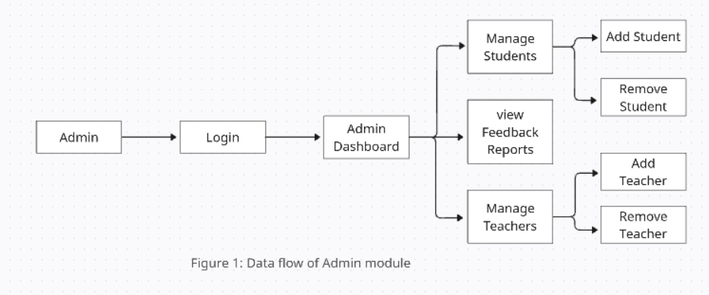
- Admin Module:

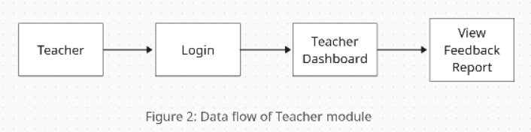
- Teacher Module:

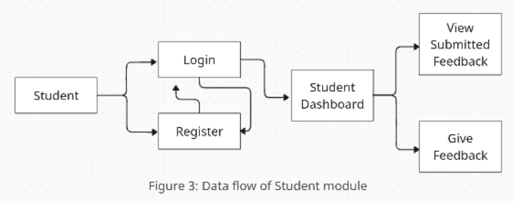
- Student Module:

